Dimensionality Reduction

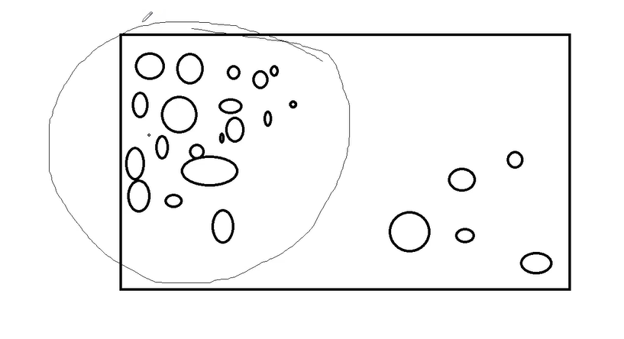
Maximum Data is clustered in one area
Eigen Value: New Dimension Values (Magnitude, Variance)
Eigen vector: Magnitude of information (Slice)
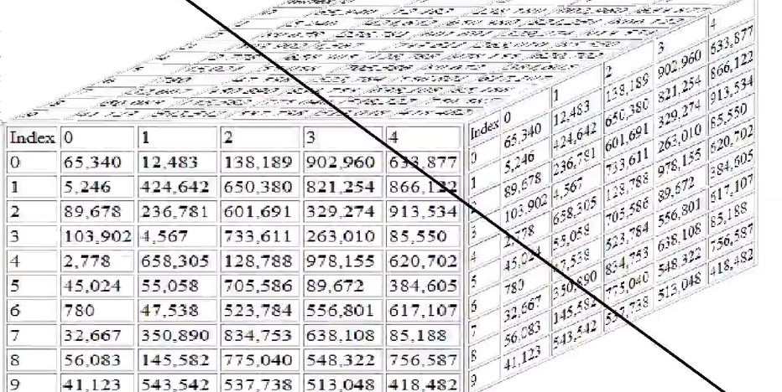

Multiple Slice

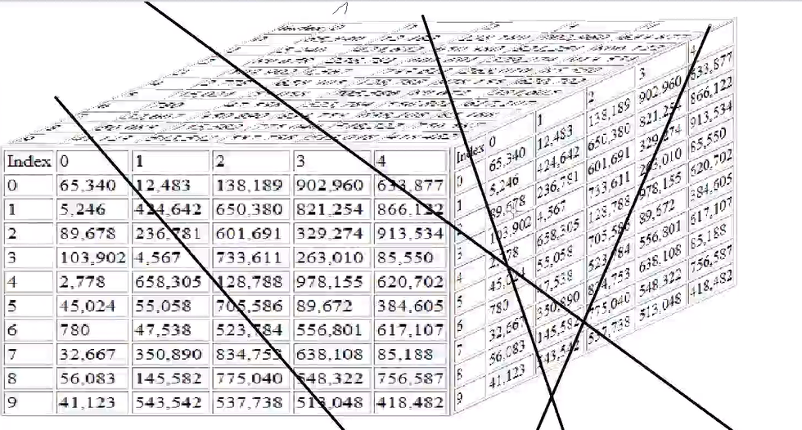
PCA - Principle Component Analysis

Dimensionality Reduction (Patient Data)

Import Libraries
import pandas as pd
import numpy as np
import matplotlib.pyplot as plt
import os

Load Data Set
os.chdir('C:\\Noble\\Training\\Top Mentor\\Training\\Data Set\\')
df = pd.read_csv('trans_us.csv', index_col = 0, thousands = ',')
display (df)

Read Normal Way

df = pd.read_csv('trans_us.csv')
display (df)

Display the Data Types
display (df.dtypes)

Load Data Set
df = pd.read_csv('trans_us.csv', index_col = 0, thousands = ',')
display (df)

Display the Data Types
display (df.dtypes)

Update Row and Column Headings
df.index.names = ['Country']
df.columns.names = ['Years']
display (df)

Check for Null Values
display (df.isna().sum())

PCA with n -components = None
from sklearn.decomposition import PCA
pca = PCA()
pca.fit(df)
print (pca)

Transform and display data
PCA1 = pca.transform(df)
display (pd.DataFrame(PCA1))

Display the variance Percentage
print (pd.DataFrame(pca.explained_variance_ratio_))

Create Model
from sklearn.decomposition import PCA
pca = PCA(n_components=2)
pca.fit(df)
print (pca)

Create PCA with two variables

PCA1 = pca.transform(df)
display (pd.DataFrame(PCA1))

Convert output to Data Frame

PCA2= pd.DataFrame(PCA1)
PCA2.index = df.index
PCA2.columns = ['PC1','PC2']
display (PCA2.head(50))

Display the variance Percentage

display (pd.DataFrame(pca.explained_variance_ratio_))

Dimensionality Reduction (Bank Data)

Import Libraries
import numpy as np
import pandas as pd
import matplotlib.pyplot as plt
import os
from sklearn.metrics import accuracy_score
from sklearn.metrics import confusion_matrix

Load Data Set
os.chdir ('C:\\Noble\\Training\\Top Mentor\\Training\\Data Set\\')
df= pd.read_csv('Bank Data Dimension Reduction.csv')
print (df)

Data Checks
print (df.isna().sum())
print ()
print (df.notna().sum())

Data Types
print (df.dtypes)

Fill missing Value Gender – Fill with Maximum Repeated value (Fill with 0)
print (df.groupby('Gender').size())
df['Gender'] = df['Gender'].fillna(0)
print ()
print (df.groupby('Gender').size())

Fill missing Value Previous

print (df.groupby('Previous').size())
df['Previous'] = df['Previous'].fillna(0)
print ()
print (df.groupby('Previous').size())

Fill missing Value Interest Rate
print (df.isna().sum())
df['Interest']= df['Interest'].fillna(df['Interest'].mean())
print ()
print (df.isna().sum())

Fill missing Value Duration

print (df.isna().sum())
df['Duration'] =df['Duration'].fillna(df['Duration'].median())
print ()
print (df.isna().sum())

Convert Gender to Category

print(df.dtypes)
df['Gender'] = df['Gender']. astype('category')
print ()
print(df.dtypes)

Convert Previous from Float to Category
print(df.dtypes)
df['Previous'] = df['Previous']. astype('category')
print ('********')
print(df.dtypes)

Convert Churn to Category and Label Encoding
print(df.dtypes)
df['Churn'] = df['Churn']. astype('category')
df['Churn'] = df['Churn'].cat.codes
print ('********')
print(df.dtypes)

Create X variable
x = df.iloc[:,1:6].values
print (x)

Create Y variable
y = df.iloc[:,6].values
print (y)

Standardization of X variable (Independent)

from sklearn.preprocessing import StandardScaler
sc_x= StandardScaler()
x = sc_x.fit_transform(x)
print (x)

Create PCA with n_components = None)
n_components = None ( Maximum Slicing , Slicing based on number of variable in this case maximum slicing is 5 – Number of Independent variables)
from sklearn.decomposition import PCA
pca = PCA(n_components = None)
PCA_X = pca.fit_transform(x)
print (pd.DataFrame(PCA_X))

PCA Percentage
print (pca.explained_variance_ratio_)

Create PCA with n_components = 2)

from sklearn.decomposition import PCA
pca = PCA(n_components = 2)
PCA_X = pca.fit_transform(x)
print (pd.DataFrame(PCA_X))

PCA Percentage
print (pca.explained_variance_ratio_)

Train Test Split

from sklearn.model_selection import train_test_split
PCA_X_train,PCA_X_test, y_train,y_test = train_test_split(PCA_X,y,test_size=0.2,random_state=42)
print (PCA_X.shape)
print (PCA_X_train.shape)
print (PCA_X_test.shape)

Display X Train as Data Frame
print (pd.DataFrame(PCA_X_train))

Create logistic model PCA applied variables
from sklearn.linear_model import LogisticRegression
logmodel = LogisticRegression()
logmodel= logmodel.fit (PCA_X_train,y_train)

Prediction
y_pred = logmodel.predict(PCA_X_test)
print (y_pred)

confusion_matrix

from sklearn.metrics import confusion_matrix
cm = confusion_matrix (y_test,y_pred)
print (cm)

Accuracy Score
print (accuracy_score (y_test,y_pred))

Create Decision Tree model PCA applied variables
from sklearn.tree import DecisionTreeClassifier
dt = DecisionTreeClassifier ()
dt= dt.fit (PCA_X_train,y_train)

Prediction
y_pred = dt.predict(PCA_X_test)
print (y_pred)
confusion_matrix and Accuracy Score

print (accuracy_score (y_test,y_pred))
from sklearn.metrics import confusion_matrix
cm = confusion_matrix (y_test,y_pred)
print (cm)

Create a model with out PCA

Train Test Split
from sklearn.model_selection import train_test_split
x_train,x_test, y_train,y_test = train_test_split(x,y,test_size=0.2, random_state=42)

Display x_train as data frame
pd.DataFrame(x_train)

Create logistic model without PCA

from sklearn.linear_model import LogisticRegression
logmodelNOPCA = LogisticRegression()
logmodelNOPCA= logmodelNOPCA.fit (x_train,y_train)

Prediction
y_pred = logmodelNOPCA.predict(x_test)
print (y_pred)

Confusion Matrix
cm = confusion_matrix (y_test, y_pred)
print (cm)

Accuracy Score
print (accuracy_score (y_test,y_pred))

Create a Decision Tree without PCA

from sklearn.tree import DecisionTreeClassifier
dtnopca = DecisionTreeClassifier ()
dtnopca = dtnopca .fit (x_train,y_train)

Prediction
y_pred = dtnopca.predict(x_test)
print (y_pred)

confusion_matrix and Accuracy Score

print (accuracy_score (y_test,y_pred))
from sklearn.metrics import confusion_matrix
cm = confusion_matrix (y_test,y_pred)
print (cm)

Conclusion: Accuracy will be more with out PCA , since considering all the variables

